**Market Basket Analysis** 10 points

***All the correct steps 5 points + Insights on Analysis 3 points***

* 1. Create a new diagram named Associations Analysis to contain this analysis.
  2. Right-click Data Sources and select Create Data Source.
  3. Change the source to metadata repository and select the BANK table in the ABA1 library.
  4. Proceed to step 6 of the Data Source Wizard.
  5. Assign metadata to the table variables as follows: change ACCOUNT to an ID role, change SERVICE to a Target role, and change VISIT to a Sequence role.
  6. An association analysis requires exactly one target variable and at least one ID variable. Both should have a nominal measurement level. A sequence analysis also requires a sequence variable.
  7. Proceed through the Data Source Wizard to the Data Source Attributes step. For an association analysis, the data source should have a role of Transaction.
  8. Select Transaction for the value of the Role field.
  9. Click Next ‘Finish’ to close the Data Source Wizard. Drag a BANK data source into the diagram workspace. Click the Explore tab and drag an Association tool into the diagram workspace. Connect the BANK data source node to the Association node.
  10. Select the Association node and examine its Properties panel.
  11. The Export Rule by ID property determines whether the Rule-by-ID data is exported from the node and whether the Rule Description table is available for display in the Results window. Set the value for Export Rule by ID to Yes.

**Correct Image as shown below (2 point)**

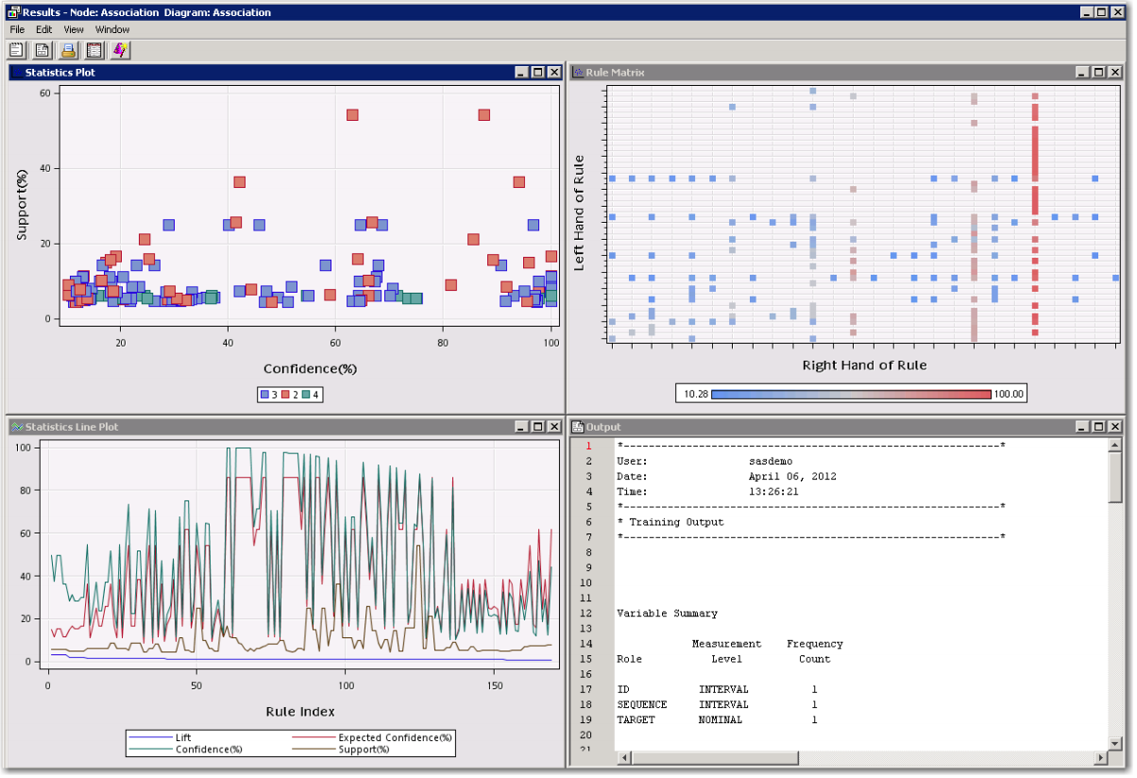

**Sequence Analysis 10 points**

***All the correct steps 5 points + Insights on Analysis 3 points***

1. Add an Association node to the diagram workspace and connect the BANK data source node to it.
2. Rename the new node Sequence Analysis. All variables now have a Use value of Yes
3. Set the Export Rule by ID property to Yes.
4. Examine the Sequence section in the Properties panel.
5. Run the diagram from the Sequence Analysis node and view the results.
6. Maximize the Statistics Line Plot window.
7. Select View  Rules  Rule description to view the descriptions of the rules
   1. The confidence for many of the rule’s changes after the order of service acquisition is considered. For example, from the rule description above, if a customer already has checking and savings, they are likely to get an ATM card next. Perhaps tying the ATM card to an additional offer for cross-sell would be beneficial. (Brief description of results)

***Correct Result as shown below (2 point)***

